CA-162W
B&W BULLET CAMERA
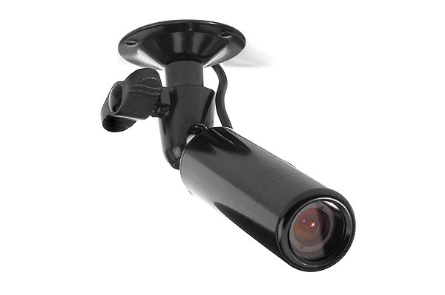
- 1/3” CCD
- 420 TV Line
- 0.02 Lux
- 4mm Lens
- 12V DC
Image Sensor | 1/3” Interline CCD
Effective Pixels | 512(H) x 492(V)
H. Resolution | 420 TV line
Min. Illumination | 0.02 Lux, F:2.0
Synchronizing System | Internal
Scanning System | 525 line, 60 field/sec
Video Output | 1.0Vp-p composite, 75Ω
S/N Ratio | More than 48 dB (AGC off)
Electronic Shutter | 1/60~100,000 sec
Gamma Correction | r=0.45
Lens | 3.6mm fixed lens
Power Source | DC 12V (± 10%)
Operation Temperature | -40°C~50°C RH 95% Max
Preservation Temperature | -40°C~60°C RH 95% Max
Power Consumption | 100mA
Dimensions | 0.9Ø x 2 inch
Case Material | Aluminum

*Above specifications and design subject to change without notification
