CA-176WHSS
HIGH RESOLUTION BULLET CAMERA
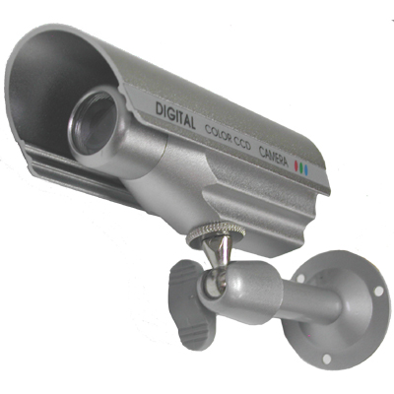
- 1/3” Sony Super HAD CCD
- Back Light Compensation
- 480 TV Lines
- 0.1 Lux at F2.0
- Weather Proof

Image Sensor | 1/3” Sony Super HAD CCD
Effective Pixels | 768(H) x 494(V)
Scanning System | 2:1 Interlace
Scanning Frequency | 15.734KHz(H), 59.94Hz(V)
Resolution | 480 TV Lines
Shutter Speed | 1/60~100,000 sec
S/N Ratio | More than 48 dB
Sync System | Internal
Min. Illumination | 0.1 Lux @ F2.0
White Balance | AWC
Lens | 3.6mm Fixed Lens
Video Output | 1.0Vp-p composite, 75Ω
Power Supply | DC 12V
Power Consumption | 140mA
Operating Temperature | -10°C ~ +50°C
Storage Temperature | -21°C ~ +60°C
Operational Humidity | Max 90% RH
Dimension(inch) | 1.6(Ø) x 4(L)

*Above specifications and design subject to change without notification
