CA-176WHVA
VARIFOCAL BULLET CAMERA
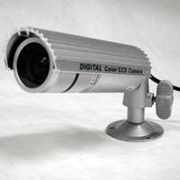
- 1/3” Sony Super HAD CCD (410K)
- 600 TV Line
- 0.1 Lux
- 4~9mm Varifocal Lens
- External Zoom/Focal Length Adjustment
- IP66
- 12V DC
Image Sensor Device | 1/3” Sony Super HAD CCD
Total Pixels | 811 x 508
Scanning System | 2 :1 Interlaced 525 Lines
Scanning Frequency | 15,734KHz(H)/ 60Hz
Shutter Speed | 1/60~1/100,000 sec)
Sync. System | Internal
Resolution | More than 600 TV lines
Video Output | VBS, 1.0Vp-p Composite
S/N Ratio | More than 48dB (AGC off)
Minimum Illumination | 0.1 Lux
Lens | 4~9mm Varifocal Lens (F=1.6)
White Balance | Auto
Operation Temperature | -10 C~50°C (14°F~122°F)
Power Consumption | DC 12V/ 70mA
Dimensions | 1.2(Ø) x 3.6(L) inch (approx.)
Weight | 0.2 lbs (approx.)

*Above specifications and appearance of product subject to change without notification
