CA-176WSS
COLOR BULLET CAMERA
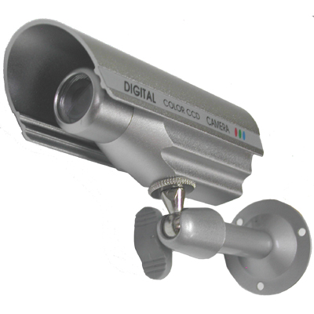
- 1/3” Sony Super HAD CCD
- Back Light Compensation
- Weather Proof (IP66)

Image Sensor | 1/3” Sony Super HAD CCD
Effective Pixels | 510(H) x 492(V)
Scanning System | 525 Lines 2:1 Interlace
Scanning Frequency | 15.734KHz(H), 59.94Hz(V)
Resolution | 420 TV Lines
Shutter Speed | 1/60~100,000 sec
S/N Ratio | More than 46 dB (AGC off)
Sync System | Internal
Min. Illumination | 0.3 Lux
White Balance | AWC
Lens | f=4.0mm F2.0 Fixed Lens
Video Output | 1.0Vp-p composite, 75Ω
Power Supply | DC 12V ±10%
Power Consumption | Max. 110mA (DC 12V)
Operating Temperature | -10°C ~ +50°C
Operational Humidity | Max 90% RH
Dimension(inch) | 1(Ø) x 3.6(L)

*Above specifications and design subject to change without notification
