CMD-143S
14” COLOR MONITOR
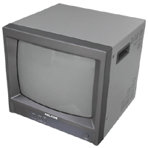
- 525 Lines of resolution
- 3 channels (2 BNC in/outputs, 1 SVHS in/output)

System | 525 lines, 60 fields / sec (NTSC), 625 lines, 50 fields / sec (PAL)
Input Signal | Composite video, sinc. Negative
Sub-Carrier Frequency Sync. Range | 3.579545 MHz ± 200Hz at room temperature
High Voltage | 24.5KV ± 500V
Convergence | Center: less than 1.0mm, Corner: less than 1.4mm
Brightness | 45ft/l (bright cont. max.)
Operating Temperature | 32 to 104 degree F, 0 to 40 degree C
Humidity | 0% to 90% (non-condensing)
Connectors | BNC (video in, out), S-VHS (video in, out), & RCA (audio in, out)
Power Source | AC 90V ~ 240V, 50/60Hz, 75W, free voltage switching power supply
Weight | Approx. 34.2 lbs
*Above specifications and design subject to change without notification

