DCK-255
PTZ KEYBOARD CONTROLLER
- 3 axis joystick
- Preset, Group. Tour programming
- Electric failure compensation
- Up to 8 sub-keyboards can be connected
- Controls up to 255 cameras

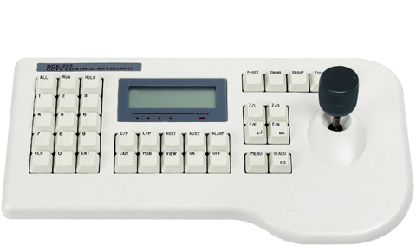
Control | Pan/Tilt, Zoom by 3-Axis Joy stic, Power, Auto Pan, AUX Control x2, Preset
Connecting Unit | Receiver(DRX-502/500), Speed Dome Camera
Communication Method | RS-485 (422)
Communication Speed | RS485 - 9600bps, N, 8, 1
Connector | Modular cable connection with junction box, Power supplied via junction box
Package | Junction Box, 5M cable (modular jacks both ends)
Operating Distance | Max. 1.2km (When using shielded twisted pair cable)
Power | DC9V, 500mA
Power Consumption | 6W
Operating Condition | 0˚C ~ +40˚C
Weight | Approx. 7.7 lbs
Dimensions | 13.5(W) x 2(H) x 6.12(D) inch
*Above specifications and design subject to change without notification

