DSC-20CMA

Corner-Mount Adapter for PTZ Dome Camera
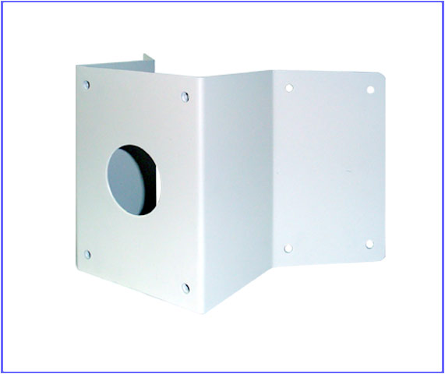

Color | Ivory
Material | Steel
Protection | Rust Proof
Weight | 2.2 LBS

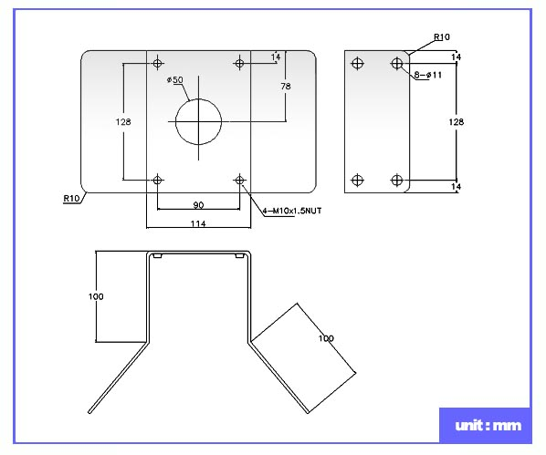

*Above specification and design subject to change without notification

