DSC-20ICB

In-Ceiling Mounting Bracket for PTZ Dome Camera
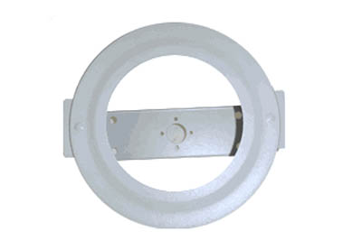
Color | Ivory
Material | Steel
Protection | Rust Proof
Thickness | 1”
Diameter | 11.2”
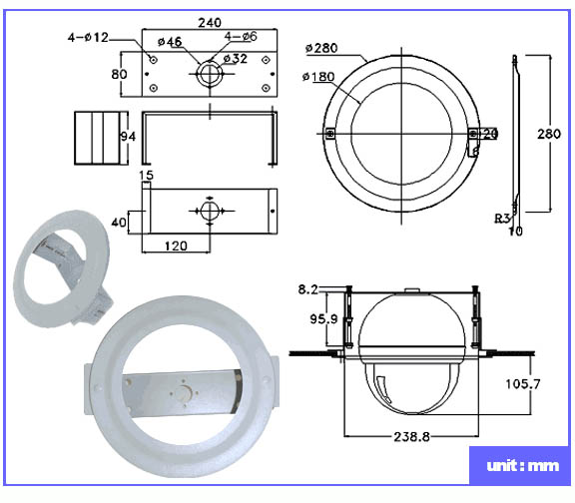

*Above specification and design subject to change without notification

