DSC-20PMA

Pole-Mount Adapter for PTZ Dome Camera

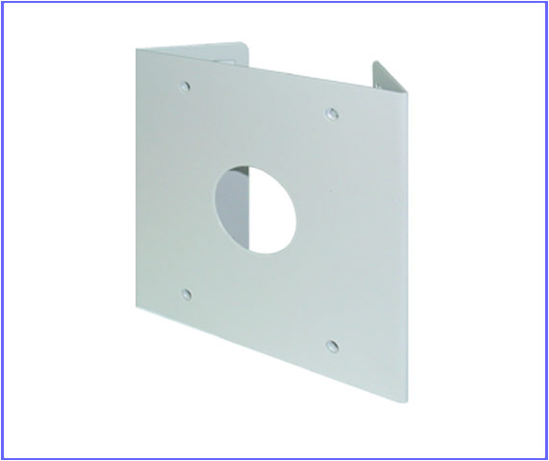

Color | Ivory
Material | Steel
Protection | Rust Proof
Weight | 6.64W x 6.6H Inch

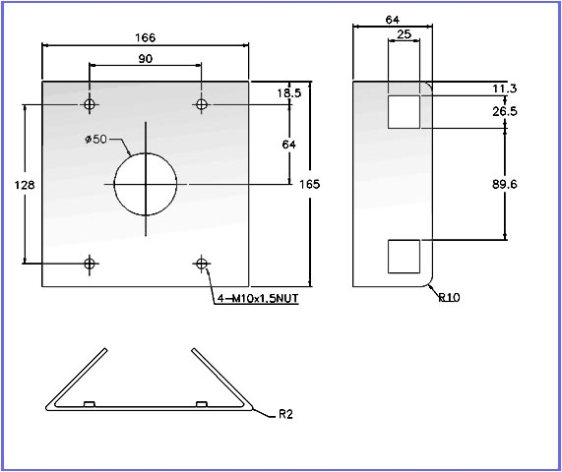

*Above specification and design subject to change without notification

