EM-171
17” B&W MONITOR
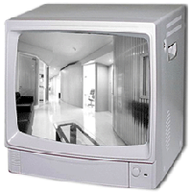
- 17” B&W picture tube
- 1000 TV Line
- Conventional front control panel
- High temperature protection circuit

Picture Tube | B/W 17" Diag.
Power Source | 90~260V AC Universal Voltage, 50 Hz or 60 Hz
Power consumption | 24 W (SMPS)
System | EIA
Resolution | 1000 TV line
Linearity | Less than 5%
Video Impedence | 75 ohm or High switch able
Video signal | Composite 0.5 ~ 2.0 V p-p, BNC
Dimension (W x H x D) | 16.7"(W) X 15.8"(H) X 15.2"(D)
Operating Temperature | 0 ~ 50°C
Operating Humidity | 0 ~ 90%RH
*Above specifications and design subject to change without notification

