GL-224A

Camera Mounting Bracket

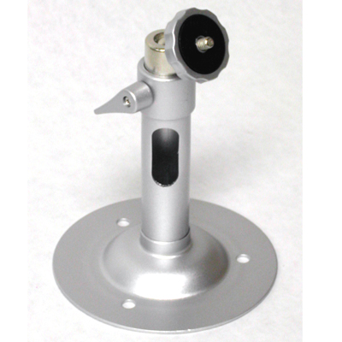
Material | Aluminum
Length | 5.2”
Maximum Load | 8.8 LBS
Swivel Angel | 360°
Tilt Angle | 90°
Color | Silver/Gray
*Above specification and design subject to change without notification

