GL-224D
EXPANDABLE CAMERA MOUNT BRACKET
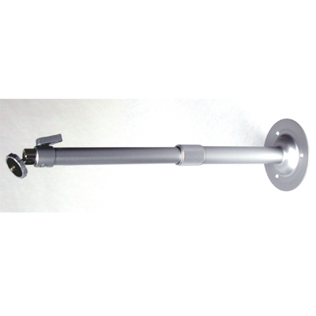
Maximum Load | 2kg (4.4 lbs)
Material | Aluminum
Color | Silver-grey
Length | 24.7~40.2 inch
Swivel Angle | 360 degree
Tilt Angle | 90 degree
*Above specifications and design subject to change without notification

