GL-605
OUTDOOR CAMERA HOUSING
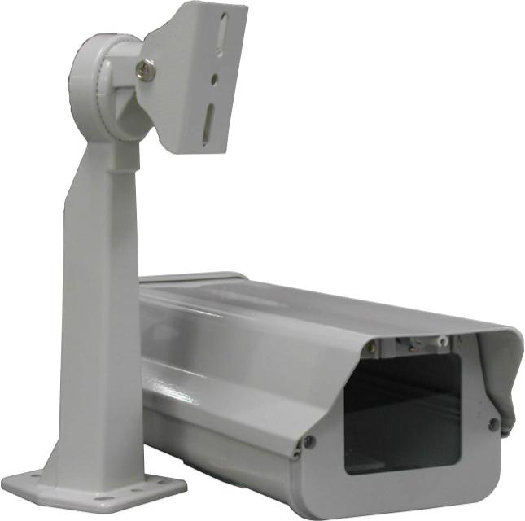
Material | Aluminum
Color | Beige
Dimension | 5.6"(W) x 4.5"(H) x 15.4"(D) /
Weight | 3.5 lbs
*Above specifications and design subject to change without notification

