GL-610
CEILING FLUSH MOUNT CAMERA HOUSING
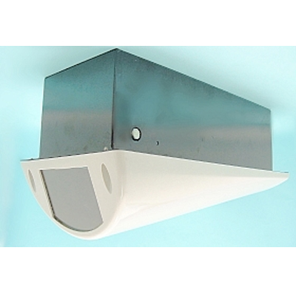
Material | Metal
Color | Beige / Black
Dimension | 5 "(W) x 4."(H) x 13.4"(D)
Inner Space | 4.5 cuft

*Above specifications and design subject to change without notification

