GL-617
OUTDOOR CAMERA HOUSING
(SIDE-OPEN TYPE)
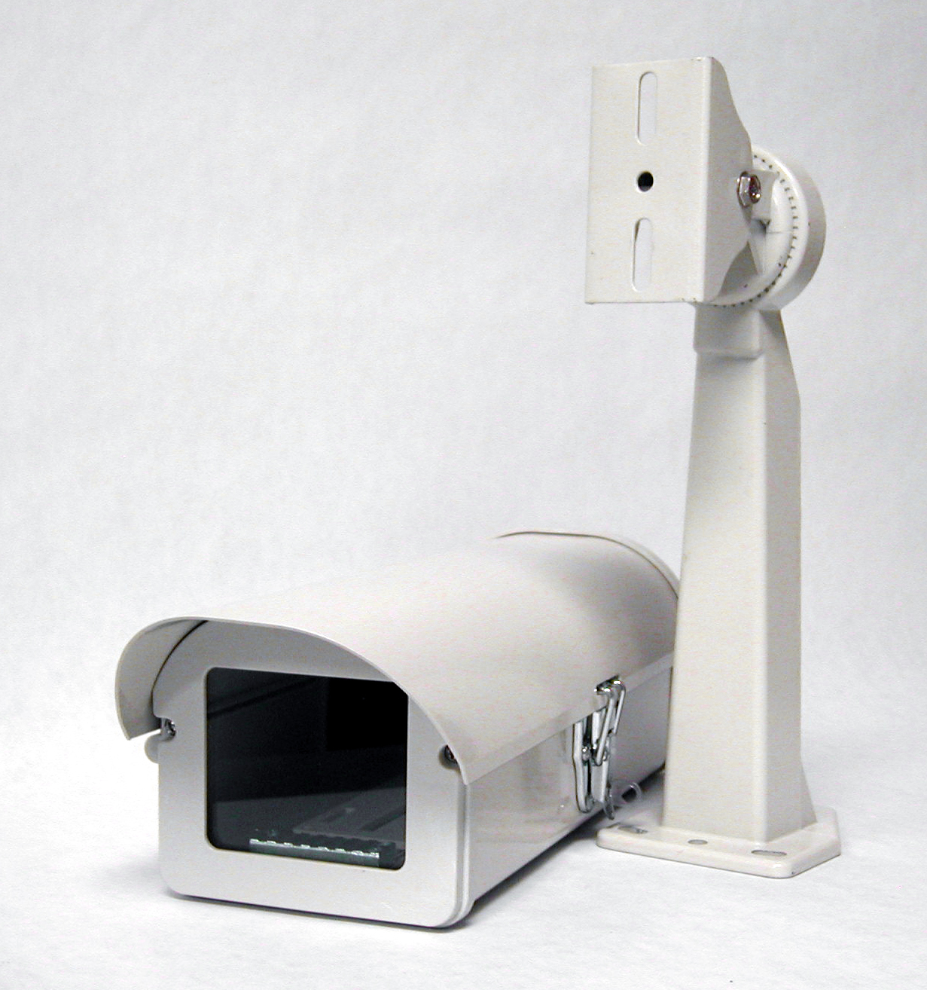
Material | Aluminum
Color | Beige
Dimension | 5.2"(W) x 3.4"(H) x 13.4"(D)

*Above specifications and design subject to change without notification

