HC-CLOCK
COLOR WALL-CLOCK HIDDEN CAMERA
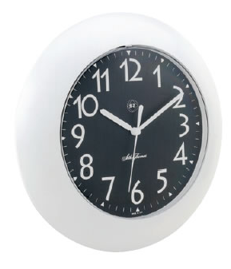
- 380 TV Line
- 0.5 Lux
- Fully Functional
- Battery Operated
- Plug & Play
Image Sensor | 1/4” Interline Transfer type
Effective Pixels | 512(H) x 492(V)
H. Resolution | 380 TV line
Min. Illumination | 0.5 Lux
Synchronizing System | Internal
Scanning System | 525 Lines 2:1 interlace
Scanning Frequency | 15.734KHz(H), 59.94Hz(V)
Video Output | VBS 1.0Vp-p 75Ω
S/N Ratio | More than 45dB or more (AGC off)
White Balance | AWB
Gamma Correction | r=0.45
Lens | 4mm pinhole lens
Power Source | DC 12V
Power Consumption | 100mA
Humidity | RH 95% Max
Operation Temperature | -10°C~50°C

*Above specifications and design subject to change without notification
