IR-018
IR ILLUMINATOR
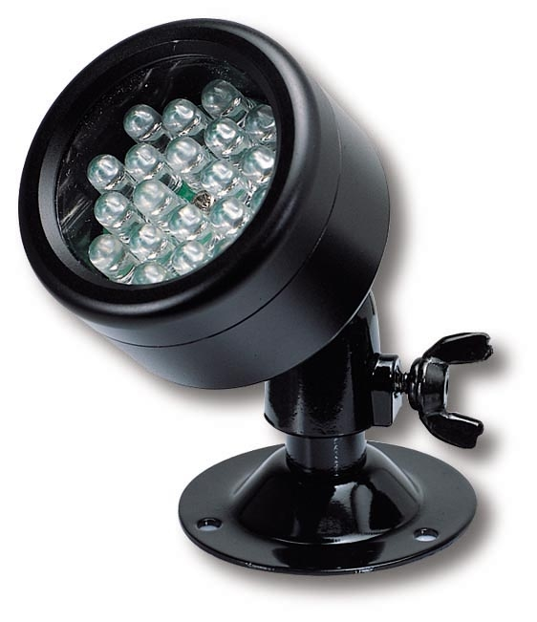
- 18 power Infrared LED lamps (850NM)
- IR range: 17 feet
- Water proof metal case
- Power supply (DC 12V 200mA) included
- Dimensions: Ø 1.8” x D 1.1”

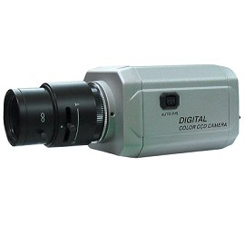

* Above specifications and design subject to change without notice

