IR-066
IR ILLUMINATOR
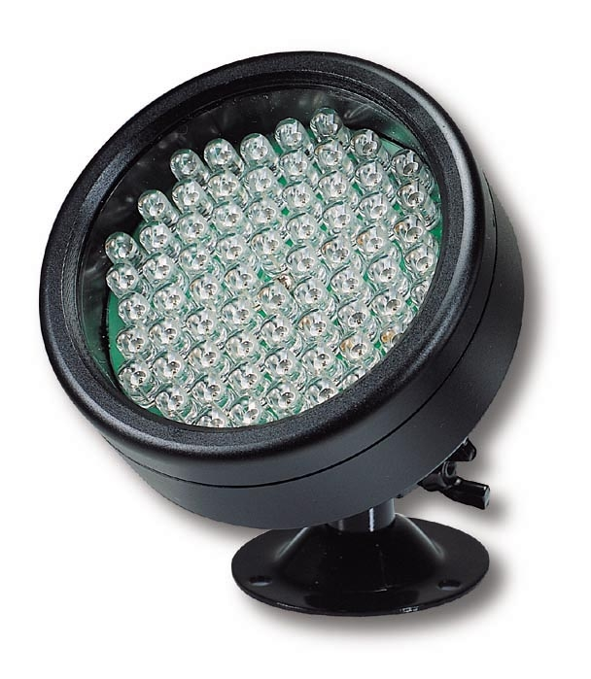
- 66 power Infrared LED lamps (850NM)
- IR range: 50 feet
- Water proof metal case
- Power supply (DC 12V 500mA) included
- Dimensions: Ø 3” x D 1.1”

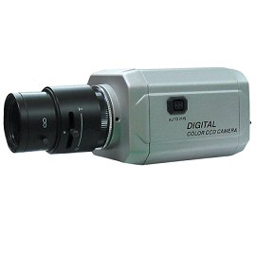

* Above specifications and design subject to change without notice

