IRC-150

IR Remote Controller & Sensor for PTZ Dome Cameras
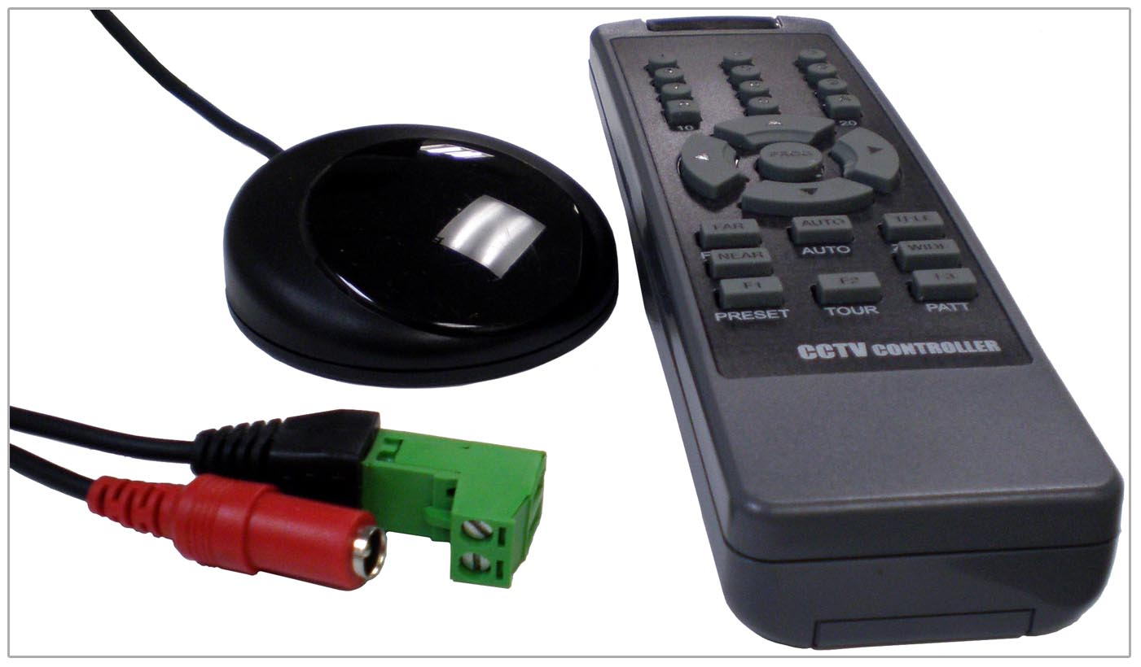

Communication | RS-485
Maximum Connection | 29 Cameras
Input Power | DC 12V 100mA
Supported Protocols | Pelco-D, Pelco-P, D-Max
Supported Baud Rate | 2400, 4800, 9600, 19200
IR Receiving Range | Almost 360°

*Above specification and design subject to change without notification

