LENS-04
4MM LENS
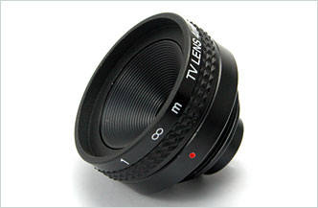
- Focal Length: 3.94mm
- F-Number: 2.5
- Sensor Size: 1/3” CCD
- Back Focal Length: 5.92 In Air
- Flange Back Length: 17.526 In Air
- Elements: 4 Glass

Focal Length |  | 3.94mm
F-Number |  | 2.5
Sensor Size |  | 1/3” CCD
Operation | Iris | Fixed
Operation | Focus | 10cm ~ ∞
Angle of View | Diagonal | 1/3”, 94°
Angle of View | Horizontal | 1/3”, 74°
Angle of View | Vertical | 1/3”, 54°
Entrance Pupil Diameter (mm) |  | 1.58
Entrance Pupil Position (mm) |  | 3.92
Exit Pupil Diameter (mm) |  | 6.28
Exit Pupil Position (mm) |  | -15.59
Back Focal Length (mm) |  | 5.92 In Air
Flange Back Length (mm) |  | 17.526 In Air
Mount Type |  | C mount
Dimensions (inch) |  | 1.4 x 1
*Above specifications and design subject to change without notification

