LENS-12
12MM LENS
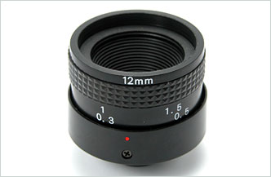
- Focal Length: 12.0 mm
- F-Number: 2.0
- Sensor Size: 1/3” CCD
- Back Focal Length: with Window
- Flange Back Length: 17.526
Focal Length |  | 12.0 mm
F-Number |  | 2.0
Sensor Size |  | 1/3” CCD
Operation | Iris | Fixed
Operation | Focus | 10cm ~ ∞
Diagonal Angle of View |  | 1/3”, 20.5°
Back Focal Length (mm) |  | With Window
Flange Back Length (mm) |  | 17.526
Mount Type |  | C mount
Dimensions (inch) |  | 1.4 x 1.2
*Above specifications and design subject to change without notification

