LENS-A3-8
3~8MM VARIFOCAL AUTO IRIS LENS
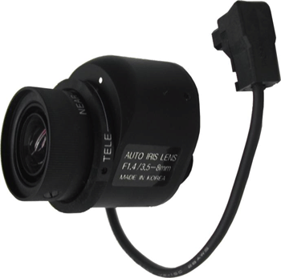
- Variable Focal Length (3 ~ 8mm)
- DC Drive Auto Iris
- Standard CS Mount

Focal Length |  | 3~8mm
Max. Aperture Ratio |  | 1:1.4
Max. Image Format Size |  | 4.8 x 3.6 (Ø 6) mm
Operation | Iris | F 1.4 ~ 360
Operation | Focus | Manual
Operation | Zoom | Manual
Angle of View | Diagonal | 118.7 ~ 44.1°
Angle of View | Horizontal | 93.4 ~ 34.6°
Angle of View | Vertical | 68.7 ~ 26.0°
Optical Distortion |  | -42.47 ~ -8.8%
Flange Back Focal Length |  | 12.5mm
Back Focal Length |  | 8.70 ~ 14.37mm
Mount |  | CS mount
Operation Temperature |  | -10~50°C
Dimensions (inch) |  | 1.8 x 2.4
Weight |  | 0.2 lbs
*Above specifications and design subject to change without notification

