MTR/LCD19
19” LCD MONITOR
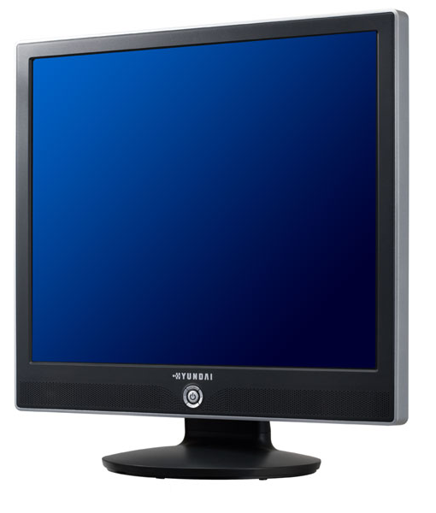
- 19 Inch Viewable SXGA(1280x1024) LCD
- Brightness 280 cd/㎡
- Contrast Ratio 500 : 1 (Typical)
- Response Time 8ms
- Analog Interface
- Built-in power supply
- Power Management (VESA DPMS)
- Plug-and-Play (VESA DDC2B Compatibility)
- TCO'03 Certified
- Support VESA Physical Mounting Interface
Size | 19 inch
Type | A-Si TFT Active Matrix
Viewing Angle (H/V) | 150/130(CR≥10)
Pixel Pitch (H/V) | 0.294 mm (H x V)
Resolution | 1280 x 1024
Contrast Ratio | 500 : 1
Luminance | 280 cd/㎡
Active Display Size (H x V) | 376.32 x 301.056 mm
Display Color | 16.2 Mil
Video | R.G.B Analog
Sync | H/V - Separate
Connector | 15 pin D-sub
Horizontal | 30kHz ~ 80 kHz
Vertical | 60~75Hz
Max. Resolution (Analog) | 1280 x 1024 @ 75Hz
Analog | 720 x 400 @ 70 Hz, 640 x 480 @ 60/72/75 Hz, 800x600 @ 56/60/72/75 Hz, 1024 x 768 @ 60/70/75 Hz, 1280 x 1024 @ 60/75 Hz
VESA Arm | 7.5 x 7.5 ㎝
Audio system | 2W x 2ch / Earphone Jack
Stand | Tilt Stand
VESA Arm | 7.5 x 7.5 ㎝
User Control | Brightness, Contrast, H/V-Position, Auto, phase, Color temperature selection,  OSD location adjustment, Language, Reset, Exit
Power Source | 100 ~ 240V AC 1.0A
Power Consumption | 60W (Max.)
Safety & Regulations | FCC, CE, CB, VCCI, UL/CUL, CCC, PSE, GOST,TUV-GS, C-Tick, NOM, BSMI, EK, MIC
Unit Dimensions & Weight | 16.9 x 17 x 7.8 inch, 10.8 lbs
*Above specifications and design subject to change without notification

