2 CH HD SDI + Full D1 8 CH Embedded DVR
NT-1030HD is High-End Hybrid Lineup of HD-SDI 2 CH and Full D1 8 CH DVR, based on H.264 Compression. This Series is Designed to Provide Users High Quality Video and High-end Level Functions. | 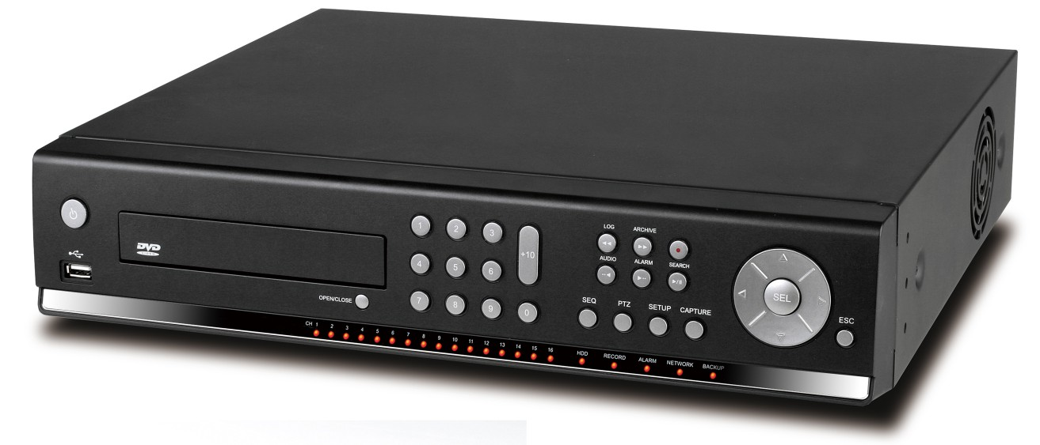

Available Model and Max. Recording Speed
Model | Recording Speed (Maximum)
Model | Hybrid: 2 CH HD-SDI + 8 CH D1
NT-1030HD | HD-SDI 720p@60fps / 1080p@30fps + D1@240fps

Specification
Description |  |  |  |  | 2 CH HDcctv + 8 CH D1
Video | Input |  |  | Channel Input Level | 2 CH HDcctv 720p / 1080p  8 CH Composite
Video |  |  |  | Video Loss Check | YES
Video | Output |  |  | Main Monitor Output | 1 HDMI (Max. 1920x1080p60 and Various Resolution)
Video |  |  |  | Sub Monitor Output | 1 VGA (Max. 1920x1080p60 and Various Resolution)
Video |  |  |  | Spot | 2 BNC
Audio | Input and Output |  |  |  | 10 CH Input & 1 CH Output
Audio | Audio Codec |  |  |  | G.711
Alarm | Sensor Input |  |  |  | 16 CH (NC / NO Selectable)
Alarm | Alarm Out |  |  |  | 1 CH out (by Sensor, Motion detection and Video Loss)
Record | Compression |  |  |  | H.264
Record | Multi Operation |  |  |  | Quadplex (Playback, Recording, Backup, Network)
Record | Resolution |  |  |  | HDcctv: 1920*1080, 1280*720, 640*360  Composite: NTSC (704x480, 704x240, 352x240)
Record | Recoding Quality Grade |  |  |  | 5 Levels
Record | Recording Mode |  |  |  | Continuous, Schedule, Motion, Sensor, Manual
Record | Motion Detection |  |  |  | Setup by Grid
Record | Pre Recording |  |  |  | 15 Seconds to 20 Minutes
Record | Post Recording |  |  |  | 10 Seconds to 60 Seconds
Playback | Multi Decoding |  |  |  | 1, 4, 8, 10
Playback | Playback Speed | Single Channel FF/FR |  |  | x0.25, x0.5, x2, x4, x8, x16, x32
Playback | Playback Speed | Multi Channel FF/FR |  |  | x0.25, x0.5, x2, x4, x8, x16, x32
Playback | Search Mode |  |  |  | Timeline, Event, Archive, Log, Specific Time
Storage | HDD | Interface |  |  | Serial ATA
Storage | HDD | Capacity of 1 HDD |  |  | 2TB
Storage | HDD | Internal HDD Number |  |  | 2 EA (4 EA without ODD))
Storage | HDD | S.M.A.R.T |  |  | HDD Error Check and Reporting using by Alarm and e-Mail
Storage | External Storage |  |  |  | 2 eSATA
Storage | File System |  |  |  | NaFS2
Storage | Backup |  | Backup Format |  | JPEG, AVI and H.264
Storage |  |  | Media |  | USB Flash Drive, USB External HDD, DVD-R, Network
Storage | Raid (TBD) |  |  |  | RAID 0/ 1 / 5 / 6 / JBOD
User Interface | Menu Display |  |  |  | GUI (Graphic User Interface)
User Interface | Input Method |  |  |  | Front Buttons, Mouse, IR Remote Control
Serial Port | Console & POS |  |  |  | 1 RS-232C (D-sub 9pin)
Serial Port | PTZ & Keyboard Control |  |  |  | 2 RS-485
Network | Dynamic DNS |  |  |  | Free DDNS
Network | Streaming |  |  |  | RTP, RTSP
Network | Protocols |  |  |  | HTTP, DDNS, NTP
Network | Network Interface |  |  |  | 10/100/1000 Base TX Ethernet (RJ45 1EA)
Network | Dual Network Streaming |  |  |  | 2 HDcctv Channel: H.264 640*360@120fps / 1280*720@120fps  8 Composite Channel: CIF@240fps / D1@240fps
Network Access | Web viewer (1:1) |  |  |  | Live, Search, Backup, PTZF
Network Access | 3G Mobile Viewer (1:1) |  |  |  | Live (iPhone, Android, Blackberry)
Network Access | Client Software (1:1) |  |  |  | Live, Search, Backup, PTZF
Network Access | Multi sites Monitoring Software(1:N) |  |  |  | Live, Search, Backup, PTZF, Remote Setup, Remote Upgrade
Features | DLS (Day Light Saving) |  |  |  | YES
Features | Internal Beep |  |  |  | By Alarm, Motion, Video Loss, HDD Error
Features | Multi Language |  |  |  | Yes
Features | Software Upgrade |  |  |  | By USB Flash Drive, Network Remote Upgrade
Features | NTP (Network Time Protocol) |  |  |  | YES
Features | Digital Zoom |  |  |  | YES
Features | Remote Setup |  |  |  | YES
General | Operation Condition |  |  |  | 5℃~40℃ (41℉~104℉), Humidity 20~80%
General | Power |  |  |  | AC 100~120V/200~240V, 50/60Hz, 280W
General | Net Weight (Gross Weight) |  |  |  | 6.8 kg (9.0 kg) / 15.0 lbs (19.8 lbs)
General | Unit Dimension (W x D x H) |  |  |  | 432mm x 430mm x 98mm (17.00” x 16.92 ” x 38.58”)
*Specifications are subject to change without notice

