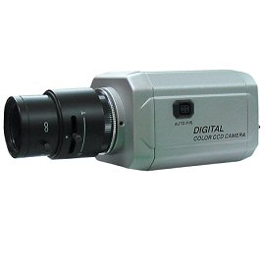
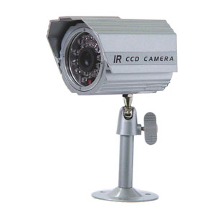

Color IR Camera with 24 Infra-Red LEDs
- 1/3” Sony Super HAD CCD
- 420 TV lines
- 0.1 Lux (CDS Sensor on 0.00 Lux)
- 12V DC
- Weather-proof
- Sunshield & mounting bracket included

Model No. | NVC-IR024
Image Pick-up device | 1/3” Color SONY Super-HAD CCD
Effective Pixels | 510(H) x 492(V)
Resolution | 420 TV lines
Sync. System | Internal
Scanning System | 525 lines, 2:1 interlace
Scanning Frequency | H:15.734KHz, V:59.94Hz
S/N Ratio | More than 45dB
Video Output | VBS Composite Video(1.0Vp-p, 75ohm)
Gamma Correction | γ = 0.45
Electronic Shutter | Auto 1/60 ~ 1/100,000 sec.
Lens | 3.6mm
Minimum Illumination | 0.1 lux (with CDS sensor on 0.00 lux)
Number of Infra-red LED | 24 IR LEDs
Power Supply | DC 12V
Dimensions (inch.) | 2.2”(W) x 2.4”(H) × 3.8”(L)
Weight | 1.4 lbs

