PBOX-DC9
9 CAMERA DC 12V POWER SUPPLY
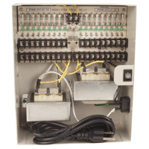
- Individual fuse and LED per output
- 12V DC
- 4A total output
- Connect up to 9 devices simultaneously
- UL listed

Power | 12V DC
Number of Output | 9
Certification | UL
Total Output | 4A
Dimensions (inch) | 9.8 x 3.8 x 8.2 (L x D x W)
Case Color | Beige
*Above specifications and design subject to change without notification

