REDX-400X
4 CHANNEL H264 STAND-ALONE DVR
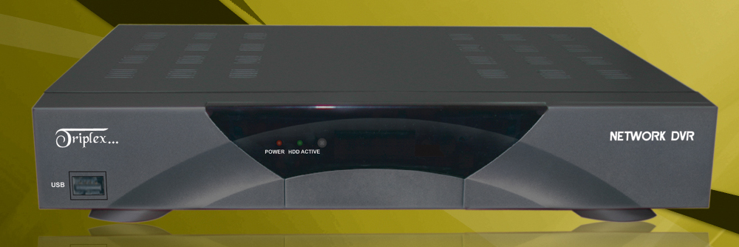
- H264 Hardware Codec
- Real Time Display
- Remote View via TCP/IP
- Mouse Control
- USB Data Backup

Multiplex | Triplex (Playback / Recording / Ethernet)
Video Input | 4
Video Output | Composite, VGA
Compression | H264 Hardware Codec
Compression Rate | 5 Steps
Live Display Speed | Real Time (30fps per channel)
Recording Mode | Schedule (Continuous, Motion, Alarm)
Search | Event, Date/Time, Percentage
Resolution | CIF (352 x 240)
Audio Recording | 1ch
Language | English, Spanish, French, Italian, German, Russian, Japanese, Chinese
Switching Interval | 1~99 sec.
Live View Display | Full Screen, Quad, Digital Zoom, PIP, Freeze, Sequence
Alarm Input | 4 (NO/NC Selectable)
Alarm Output | 1 (NO/NC)
Post Alarm | 2~99 sec. selectable
Motion Area | 30 x 24
Network | Ethernet (TCP/IP), View Program only (no Internet Explorer)
Backup | USB, TCP/IP
PTZ Control | RS-485
Firmware Upgrade | USB
Operation | P/S2 Mouse, network
Power Requirement | DC 12V 3.33A
Weight | 4.4 LBS
Dimensions | 14.8(W) x 10.4(H) x 2.5(D) inch
*Above specifications and design subject to change without notification

