SIR-012
LONG DISTANCE IR ILLUMINATOR
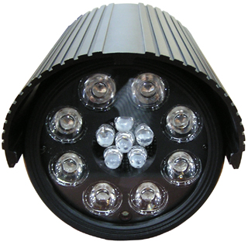
- High Sensitivity Professional LEDs
- 400ft IR Range
- IR Lux Selection Switch
- IR Sensitivity Level Switch
- Low power consumption
- Dual Voltage

LED | 850nm, 8pc of 50 degree 25mm Collimator & 6pc of 30 degree 10mm
IR Range | 400ft outdoor
Lifetime | 10,000 hrs
Power Source | Dual Voltage 1.5A
Power Consumption | Normal 15 watts (1200mA / 12V)
Operating Lux Level | Selectable by switch on the back side
Output Terminal | 5ft DIY cable
IR Option | IR Lux Selection / IR Sensitivity / IR on or off
Operating Temperature | -13F~104F (-25C~50C)
Storage Temperature | -22F~140F (-30C~60C)
Operating Humidity | up to 85% RH
Dimensions | 4.4W x 4.4H x 6.2L inch
Weight | 4lbs
Material | Aluminum casting/extrusion

*Above specifications and design subject to change without notification

