SK-2005
B&W MINI SQUARE CAMERA
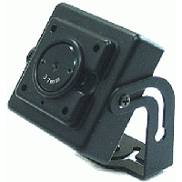
- 1/3” Sony CCD
- Compact Size (1.2” x 1.2”)
- Video, audio, and power cable included
- 3.7mm Lens
- 12V DC
- Audio Output
- Built-In Microphone
Image Sensor | 1/3” B&W CCD
Effective Pixels | 510(H) x 492(V)
H. Resolution | 400 TV line
Min. Illumination | 0.5 Lux
Audio Gain | 40dB±2dB
Audio Max Output | 600 Ohm Max. 3Vp-p
Frequency Response | 300Hz~20,000Hz
Audio S/N Ratio | -45dB±10%
Synchronizing System | Internal
Scanning System | 2:1 interlace
Video Output | 1.0Vp-p (sync. Negative) termination 75Ω
S/N Ratio | More than 45dB or more (AGC off)
Gain Control | Automatic
Electronic Shutter | 1/60~100,000 sec
Gamma Correction | r=0.45
Lens | 4.3mm fixed lens, f/2.0
Power Source | DC 12V
Power Consumption | Max 110mA
Reverse Polarity Protection | Yes
Humidity | RH 95% Max
Preservation Temperature | -40°C~60°C RH 95% Max
Operation Temperature | -10°C~50°C
Dimensions | 1.2 x 1.2 inch
Case Material | Aluminum

*Above specifications and design subject to change without notification
