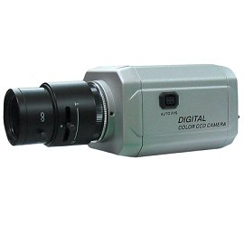
VPD-411VADN
Color Vandal Proof Dome Camera
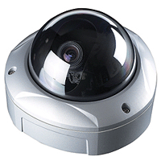
- 1/3” Sony CCD
- 600 TV lines
- Day & Night
- 3.8 ~ 9.5mm Varifocal Auto Iris Lens
- 12V DC

Image Sensor | 1/3" Interline transfer type color CCD (Sony)
Effective Pixels | 811H × 508V (380K pixels)
Scanning System | 525 Lines 2:1 Interlace
Scanning Frequency | 15.734KHz (H), 59.94Hz (V)
Resolution | 600 TV-Lines
Shutter Speed | 1/60 ~ 1/100,000sec.
S/N Ratio | More than 48dB (AGC off)
Sync. System | Internal
Min. Illumination | 0.5 Lux (F1.3)
White Balance | ATW/AWB
Video Output | VBS 1.0 Vp-p (75Ω load)
Lens | 3.8mm~9.5mm Vari-Focal DC Auto Iris (F1.3)
Power Supply | DC12V ±10%
Power | 180mA (DC12V)
Operating Temp. | -10℃ ~ +50℃
Operating Humidity | 90% RH max.
Dimensions | 5.8(Ø) x 4(H) inch
Weight | 3.4 lbs (approx.)

*Above specifications and product design subject to change without notifications

