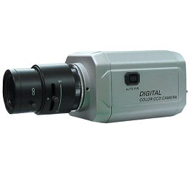
VPD-IR024HVA
Color Vandal Proof IR Dome Camera
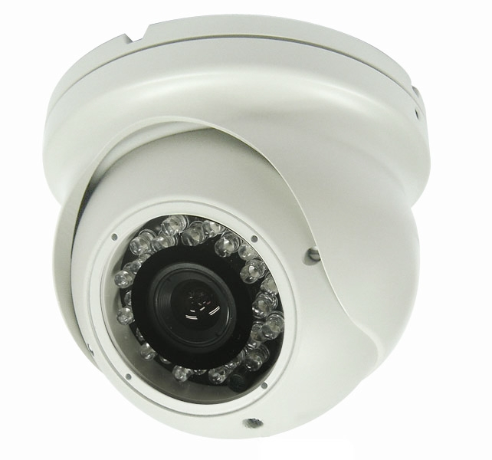
- 1/3” Sony Super HAD CCD
- 600 TV lines
- 24 IR LEDs
- 4 ~ 9mm Varifocal Lens
- 12V DC
- Easy camera adjustment

Image Sensor | 1/3" Sony Super HAD CCD
Effective Pixels | 811H × 508V
Resolution | 600 TV-Lines
Shutter Speed | 1/60 ~ 1/100,000sec.
Iris Control | Auto
Gamma Characteristic | r=0.45
S/N Ratio | 45dB
Sync. System | Negative Sync., Internal
Min. Illumination | 0.1 Lux (CDs on: 0 lux)
Video Output | 1.0 Vp-p Composite Video (75Ω load)
Lens | 4mm~9mm Vari-Focal
Backlight Compensation | Auto
AGC | Auto
Power Supply | DC12V ±10%
Power Consumption | 450mA Max (DC12V)
Operating Temp. | -10℃ ~ +50℃
Operating Humidity | 90% RH max.
Dimensions | 4.8(Ø) x 4(H) inch (approx.)
Weight | 1.8 lbs (approx.)

*Above specifications and product design subject to change without notifications

