VPD-IR024HVM
Vandal Proof IR Dome Camera
2.8~12mm Manual Iris Varifocal Lens
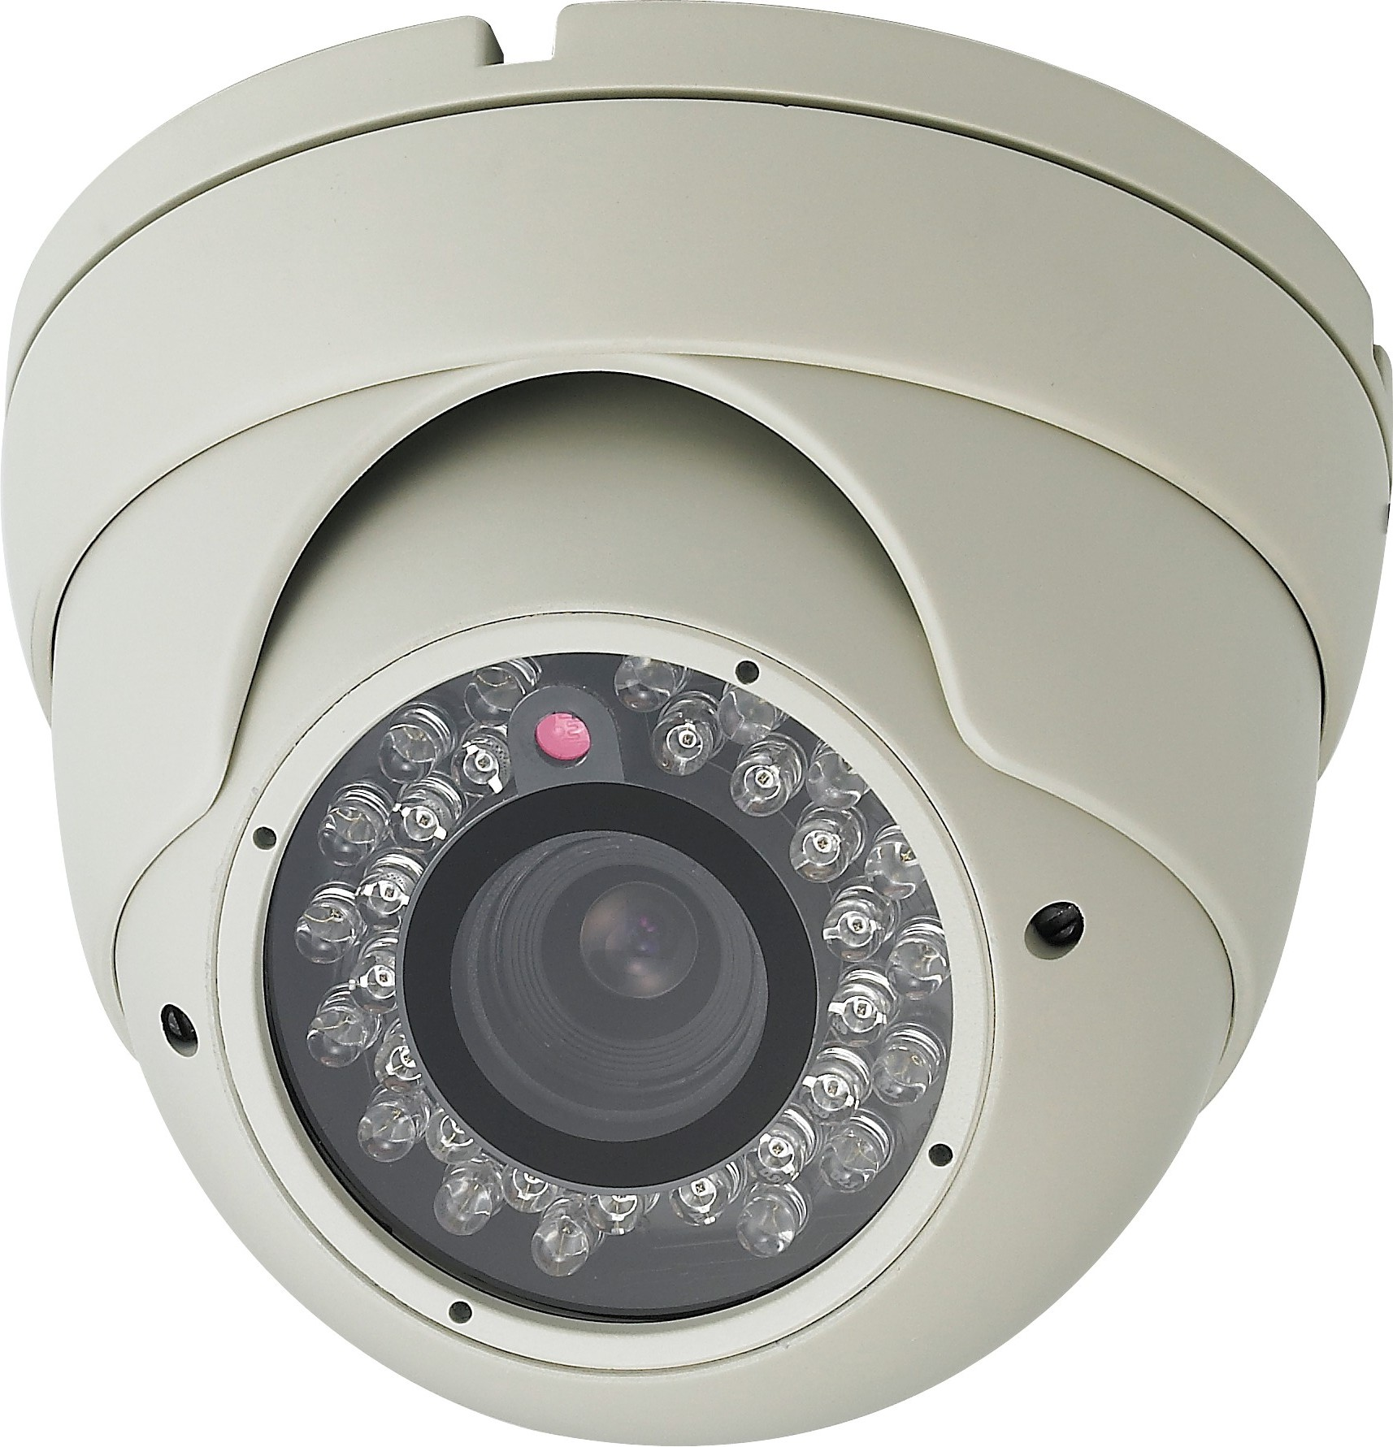
- 1/3” Sony Super HAD CCD
- 650 TV lines
- 24 IR LEDs
- 2.8~12mm Varifocal Lens
- 12V DC
- Easy camera adjustment

Image Sensor | 1/3" Sony Super HAD CCD
Effective Pixels | 811H × 508V
Total Pixels | 768H x 494V
Scanning System | 2:1 Interlaced 525 TV Lines
Scanning Frequency | 15,734KHz (H) / 59.94Hz
Shutter Speed | 1/60 ~ 1/100,000sec.
Sync. System | Internal
Resolution | 650 TV-Lines
White Balance | ATW
Backlight Compensation | On / Off
Flickerless | On / Off
AGC | On / Off
Video Output | 1.0 Vp-p Composite Video (75Ω load)
S/N Ratio | 45dB
Min. Illumination | 0 Lux for Infrared Lighting Conditions
IR Range | 60ft
Iris Control | Auto
LED Quantity | 24 pcs
Gamma Characteristic | r=0.45
Lens | 2.8mm~12mm Vari-Focal
Operating Temp. | -10℃ ~ +50℃
Power Consumption | DC 12V 110mA (CDS On: 420mA)
Dimensions | 4.8(Ø) x 3.9(H) Inch (approx.)
Weight | 1.8 lbs (approx.)

*Above specifications and design subject to change without notice

